User Role: Admin - juliustolentino.diamond@gmail.com
Pass- julius123!

LIST OF ACCOUNTS TEST
lmstest.mel01@gmail.com
Lmstest01 -USED AS STUDENT

daniel.mitchell9412@gmail.com
Qollabai2026 -USED AS ADMIN

luna.akirapogi@gmail.com
Qollabai2026 -USED AS FACULTY

matthewcauso@gmail.com
Qollabai2026 -USED AS REGISTRAR

VID: https://drive.google.com/drive/folders/1IGZGVvq1a-VgLGDGSpNdHnkfA_tSioMf?usp=sharing
—

- Switch roles
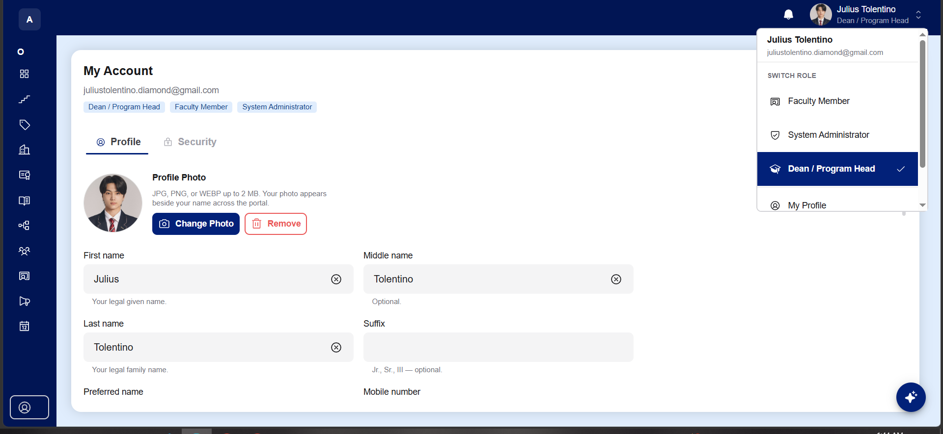

ERRORS: | Having multiple roles can cause a disaster, including overlapping their roles and their job if for example theirs a problem on someone's account that needs mediate action, and the admin is busy teaching and causing a delay on both sides.
SUGGESTION: | Remove the switch roles, maybe faculty and dean can be- if the dean is also a faculty member but not 3 roles and it can cause confusion and overlap their works. There's also IT Server that can take over the admin
MODULE | Switch

- Dashboard
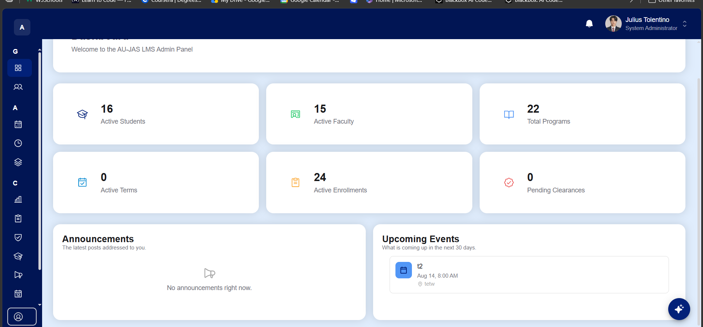

ERRORS: | Cannot click total program, active enrollment and pending clearance.
SUGGESTION:
MODULE

- Academic Years
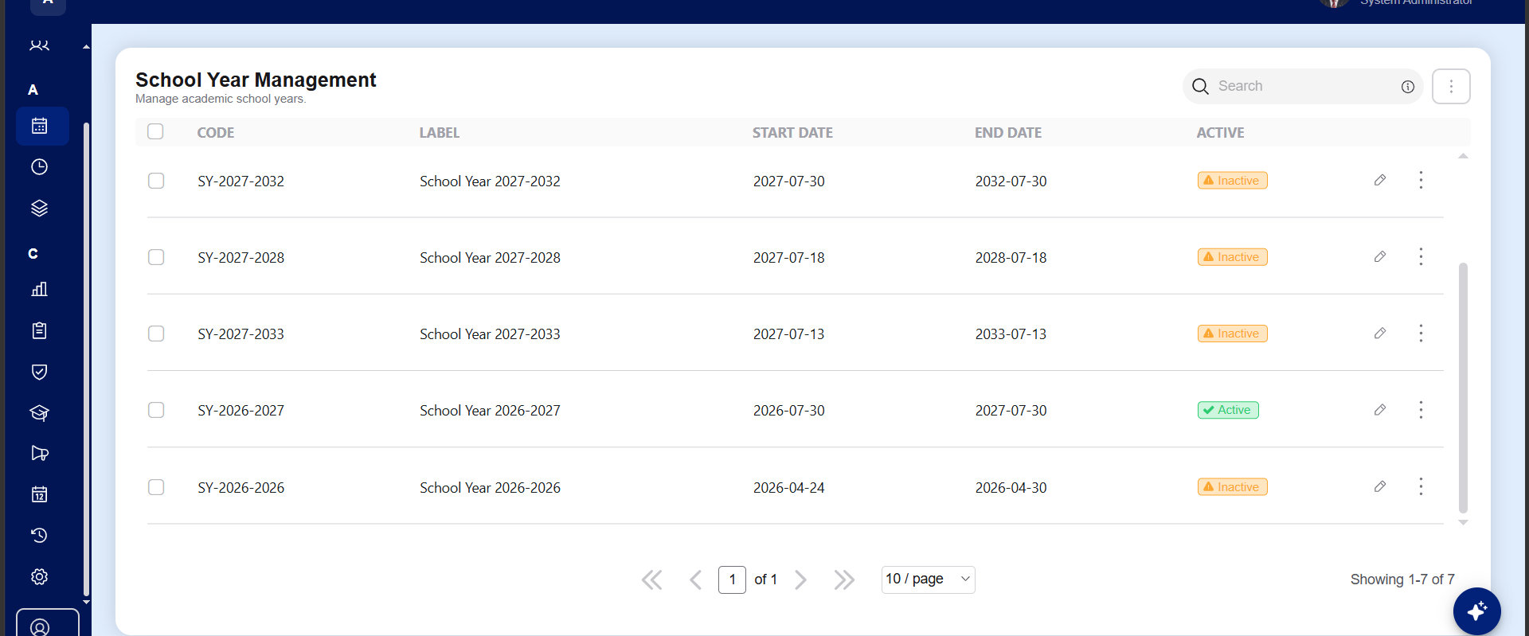

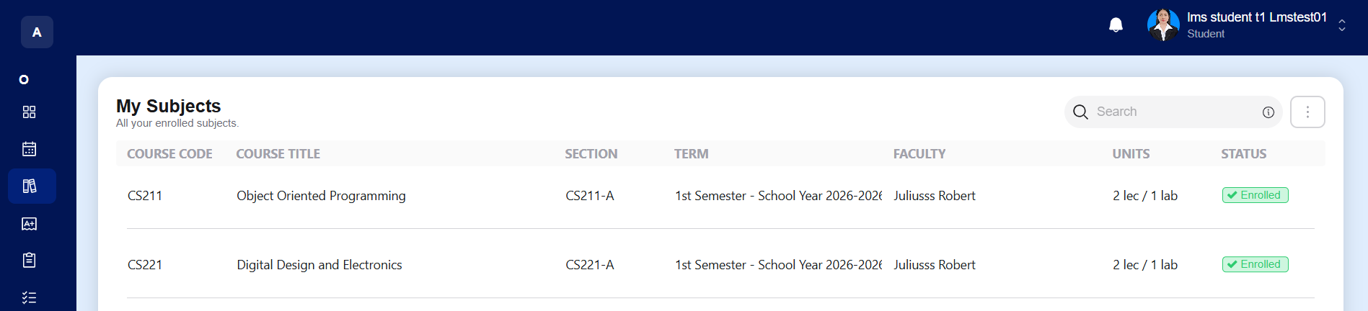
ERRORS: | The “school year 2026-2026” is not active in the admin panel, but it shows the student if it is enrolled, it shouldn’t be enrolled and not showing.  It should be 2 active on the admin “school year 2026-2027” and “school year 2026-2026”, i cannot activate both school year.
SUGGESTION: | Can activate 2 school year, 1 for the school year (1 year) and 2 for the summer school(for incoming 4th year).
MODULE

- Evaluation
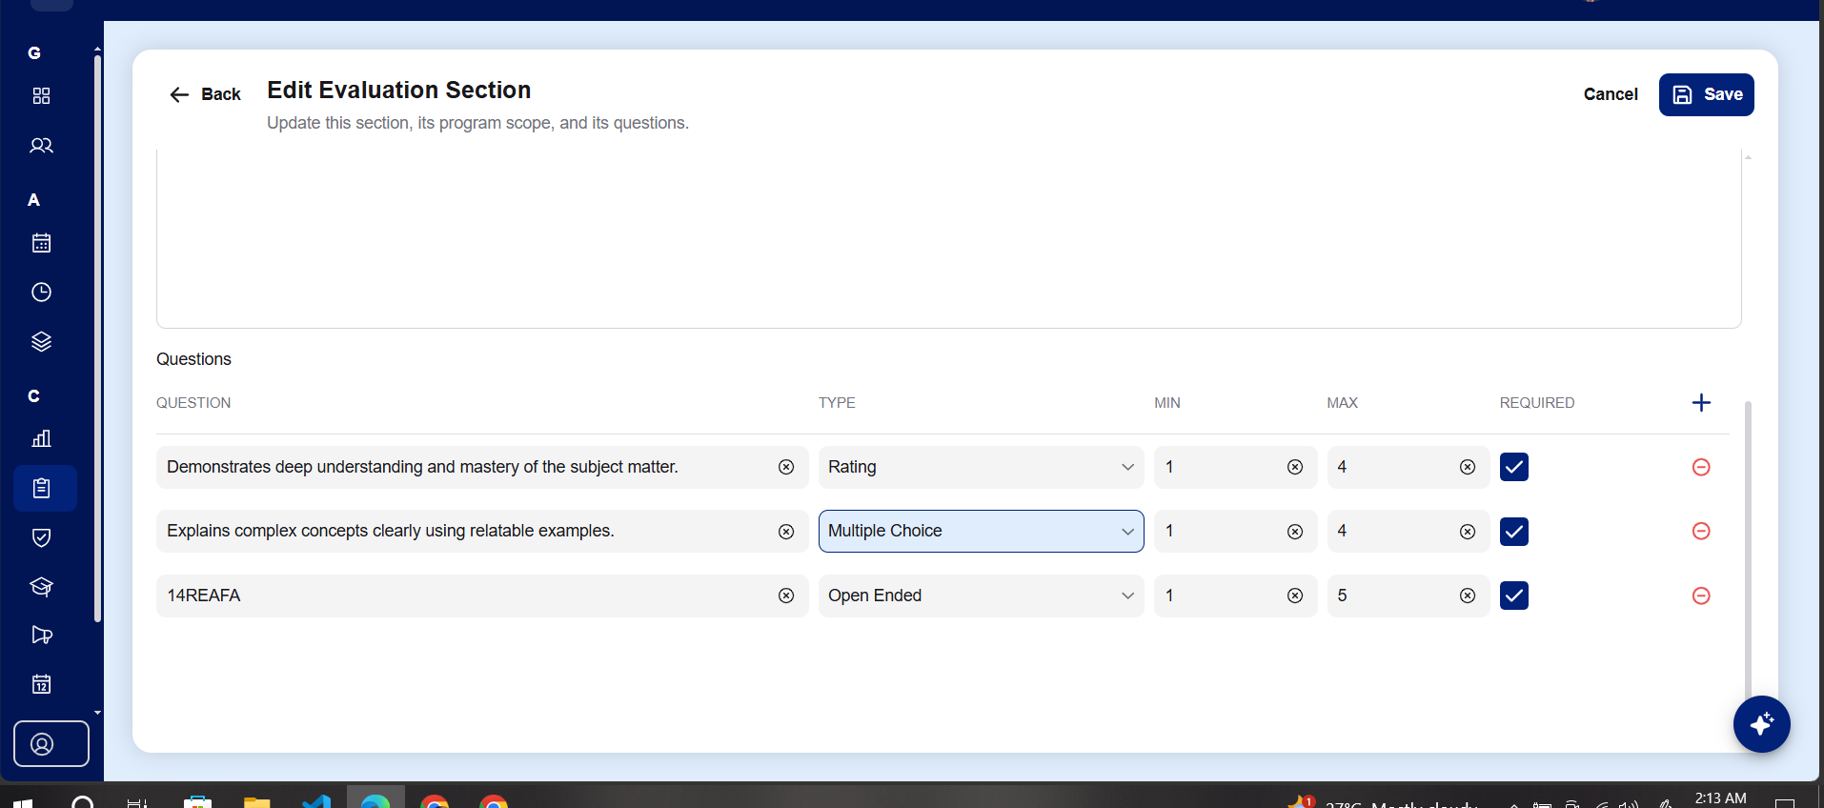

ERRORS: | It doesn’t show multiple choices that can be edited.
SUGGESTION:
MODULE

- Dashboard
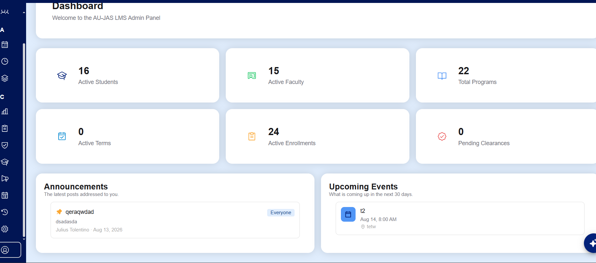
ERRORS: | Cannot click announcement
SUGGESTION:
MODULE | Announcement

- Audit
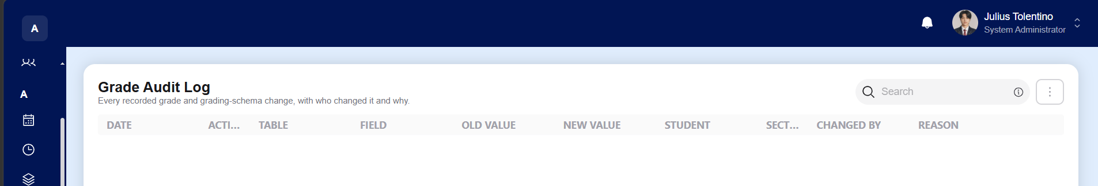
ERRORS: | Cannot see the whole name or read.
SUGGESTION: | Able to read the whole word.
MODULE | Grade audit

- Profile
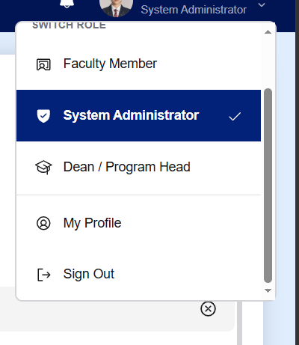

ERRORS: | Don’t need my profile coz it's already on the left side of the screen.
SUGGESTION: | Just keep one my profile, don’t need 2 “my profile”

